Introduction




Chemical explosives are substances that will burn up or be decomposed almost instantly; this produces intense heat and a large volume of expanding gas. These explosives are generally used for construction and in war (Johnson, 2014). Chemical weapons and explosives present an immediate threat to public health and safety therefore the detection of these explosives would allow for prevention of disaster (Coffey, 2015). Gas chromatography and mass spectrometry prove to be efficient ways to measure and detect these substances.

Gas Chromatography





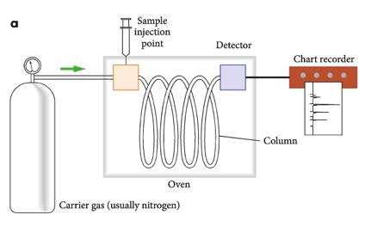
Gas chromatography is use to separate volatile components of a mixture. A small amount of a sample is drawn up in a syringe to be analysed. After being changed into its gas form through exposure to high temperatures this sample is then injected. A carrier gas (often helium or nitrogen) flows through the injector and pushes the gas component of the sample into the gas chromatography column. Inside this column is where the separation takes place. Molecules change between the carrier gas (mobile phase) and the high boiling liquid (stationary phase) within the column. After going through the column the sample reaches a detector, different components of this sample, depending on its element reaches this detector at separate times this is called the retention time (Murphy, 2001) (Figure1). The whole sequence is also recorded as a series of peaks on a chart (Figure 2). Individual chemicals can be identified by the amount of time they take to pass the column. The areas of the peaks can also be used to measure the amount of material detected (Liebenson, 2001).


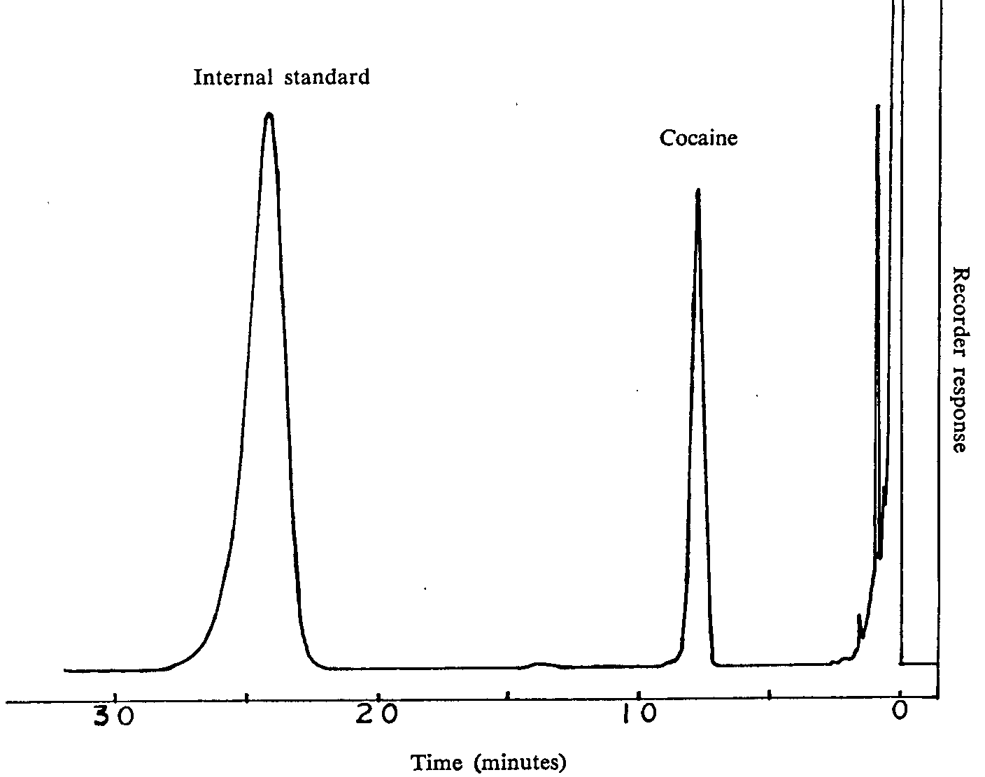
Figure 1 (Christie, 1989)
Figure 2-(Davis, Disney, Hayes, Smith & Whan, n.d).
Mass Spectrometry


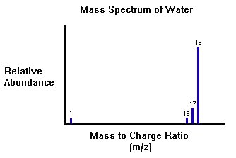
Mass spectrometry is another way of analysing elements. This method is based on the different masses of atoms in a sample (Figure 3). This procedure can determine what elements are present in a sample or what isotopes are present in an element. UV light or high-energy electrons bombard a sample thereby removing electrons leaving the atom with a positive charge. All atoms would become positive after this process meaning that the type of element wouldn’t affect the efficiency of the mass spectrometer. Positive ions in this sample are then accelerated though an electric field, moving at high speed. Then the sample passes through a magnetic field and undergoes deflection according to their masses. Lighter masses are deflected more often than heavier masses (Davis, Disney, Hayes, Smith & Whan, n.d). The mass spectrum of a compound consists of a series of peaks that differ in height (Figure 4). These differences depend on the relative number of ions of difference mass values. On each spectrum, the highest peak often corresponds to the mass of the positive ion of the compound itself. The rest of the spectrum peaks obtained are progressively smaller and smaller fragments. Compounds can be identified from their mass spectra by the shape and the distribution of various peaks (Liebenson, 2001)
Figure 3 (McGraw-Hill Companies)
Figure 4 (UC Davis)





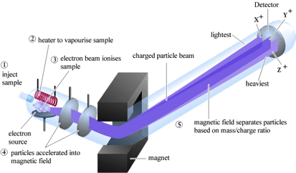

Data Analysis of GC/MS




If a GC machine is linked to a mass spectrometer, this combined GC-MS method allows the separated substances leaving the column of the GC machine to be detected (Bbc.co.uk, n.d). An experiment was conducted to test the use of GC/MS as a method of detecting and positively identifying elemental sulphur as a part of explosives analysis. This experiment took samples of both unburned and burned explosive mixtures to examine. The experiment tested both flash powder and black powder. A small sample of each was taken and analysed. The GC/MS was able to positively identify elemental sulphur in all samples (Bradley, n.d). The results of the flash powder can be seen in (Figure 5). The two left (A) and (B) chromatograms are the total ion current chromatograms for unburned and burned flash powder. For the unburned flash powder, there is one large peak with retention time around 5 min, and its fragmentation pattern is shown in (B). The peak is positively identified as elemental sulphur, with a high match quality. For burned flash powder, there is a small peak at around 5 min that is surrounded by more peaks. The fragmentation pattern for this peak is shown in (D). Fragments indicative of sulphur are clearly visible, and elemental sulphur is positively identified with another high match quality (Bradley, n.d).

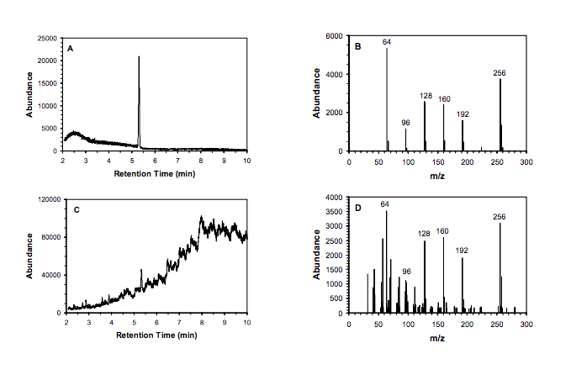
Figure 5 (Bradley, n.d)

Detecting Traces of Chemical Explosives



When analysing a sample to detect traces of chemical explosives, since there is a wide variety of possible types of explosives available noble gases and alkali metals of which are commonly used in chemical explosives are what is being tested for (Rankin, n.d). So when a sample is taken from a particular scene where explosives are suspected of being used it would go through the gas chromatograph then through the mass spectrometer. After this the data is then analysed and compared to elements such as alkali metals.

Conclusion


Chemical explosives, being a threat to the health and safety need to readily detected and dealt with. Along with the use of GC/MS we are able to efficiently identify these explosive traces. During gas chromatography a sample is used to take this substance and allow for us to record individual chemicals. Then the mass spectrometer analyse these elements through recording its mass and thereby the samples potential threat. Overall this method is found to be a very effective way to detect chemical explosive traces.

References
Bbc.co.uk,. BBC - GCSE Bitesize: GC-MS. Retrieved 25 March 2015, from http://www.bbc.co.uk/schools/gcsebitesize/science/add_aqa/atomic_structure/analysing_substancerev2.shtml

Bradley, K. Determination of Elemental Sulfur in Explosives and Explosive Residues by Gas Chromatography-Mass Spectrometry (1st ed.). Springfield Forensic Science Laboratory. Retrieved from http://projects.nfstc.org/trace/docs/Trace%20Presentations%20CD-2/bradley_paper.pdf
Christie, W. (1989). Gas Chromogram. Retrieved from http://www.unodc.org/images/odccp/bulletin/bulletin_1979-01-01_1_page009_img002_large.gif
Clark, J. (2000). the mass spectrometer - how it works. Chemguide.co.uk. Retrieved 23 March 2015, from http://www.chemguide.co.uk/analysis/masspec/howitworks.html

Coffey, M. (2015). Chemical and Explosives Detection. Aps.org. Retrieved 23 March 2015, from http://www.aps.org/about/governance/task-force/counter-terrorism/coffey.cfm
Davis, A., Disney, A., Hayes, V., Smith, D., & Whan, R. Nelson chemistry units 1 & 2 for the Australian curriculum (pp. 131-132,293).
Dunnivant, F., & Ginsbach, J. (2011). GCMS: A Basic Introduction. People.whitman.edu. Retrieved 23 March 2015, from http://people.whitman.edu/~dunnivfm/C_MS_Ebook/CH5/index.html
Johnson, N. (2014). explosive | chemical product. Encyclopedia Britannica. Retrieved 23 March 2015, from http://www.britannica.com/EBchecked/topic/198577/explosive

Liebenson, M. (2001). Analytical Chemistry. In The World Book Encyclopedia of Science: Chemistry. Chicago: World Book.
McGraw-Hill Companies,. Mass Spectrometer. Retrieved from http://www.mhhe.com/physsci/chemistry/carey/student/olc/ch13ms.html
Rankin, S. Forensic Science Central � Explosives. Forensicsciencecentral.co.uk. Retrieved 26 March 2015, from http://forensicsciencecentral.co.uk/explosives.shtml
UC Davis,. Retrieved from http://chemwiki.ucdavis.edu/Analytical_Chemistry/Instrumental_Analysis/Chromatography/Gas_Chromatography

CONTENT
Aspect | 0 marks | 2 marks | 4 marks | 6 marks
How the instrument works | Describes a general principle of how machine works but lacks many details | A diagram shows the parts of the instrument and some information is given about what the different parts of the instrument do. | A diagram shows the function of the machine and information is given about the role of different parts of the instrument. Some description of chemical principles underpinning how the machine works using appropriate terminology (e.g. emission and absorption for AAS, elution and retention for GC-MS) | The function of each part is clearly described with details that show a level of research (i.e. not just paraphrased from textbook). Gives elaborate background into the chemical principles relevant to the analytical method (e.g. energy levels and absorption spectra for AAS, chromatographic principles for GC, etc.)
How data from the instrument is used | No explanation of how the output from the machine is used | Describes the type of output generated by the instrument. | Describes how the output of the instrument can be used to analyse, identify or detect substances and includes an appropriate image/table. | Explains how the results are used to analyse, identify or detect substances. Includes example AAS data or GC-MS data and demonstrates how this would be used for the particular application described.
Description of application | Lists the chosen application | Explains the importance of the chosen application. | Explains the importance of the chosen application and describes the chemistry of the substances which need to be analysed.

COMMUNICATING THROUGH ACADEMIC WRITING:
Aspect | 0 marks | 1 mark | 2 marks
References list | - | Most references are correctly formatted using APA. Occasional minor problems. | All references correctly formatted using APA. No errors in referencing details.
In-text citations | - | Some attempt to use in-text citations but some parts are missing citations. | All information that is not common knowledge is attributed using a form of in-text citations.  PART 2: ASSIGNMENT  Content = 14 / 16  Communication = 6 / 8  Total = 20 / 24  This will be combined with your mark in the validation test to achieve a total score /100.
Sources | - | At least three sources are used including at least one text source.
Conventions for figures and tables | - | Includes at least one figure or table. All figures and tables are labelled, include captions and sources, and are referenced in the main text.
Headings | - | Divides report into logical sections using headings.
Writing | - | High quality presentation of writing with minimal spelling or grammar errors

